**FOOD BLOG**

***Submitted by***

**Monica S 19CS058**

*A report for the Engineering Exploration-I of the project*

*Submitted to the Faculty of*

**INFORMATION AND COMMUNICATION ENGINEERING**

***In partial fulfillment for the award of the degree***

***of***

**BACHELOR OF ENGINEERING**

**IN**

**COMPUTER SCIENCE AND ENGINEERING**

**SRI SHAKTHI**

**INSTITUTE OF ENGINEERING AND TECHNOLOGY**

**COIMBATORE – 641 062**

**Autonomous Institution, Accredited by NAAC with “A” Grade**

**JANUARY 2020**

**ABSTRACT**

This project is a precursor for a potential food ordering site. The concept that has been attempted to be highlighted through this project is the importance of recognizing the indigenous cuisine of the country. The project showcases only indigenous foods as the choices available to the user at present. The system also has an in-built billing option that the user will be navigated to on clicking the image of any item. The site has been provided with a clear user-friendly interface. The images of the respective food items have been arranged into concise categories and further arranged into rows with punchy descriptions about the food item making the site more interesting and likable. The e-commerce guidelines of India prescribe only certain specific details to be collected from the user at the time of billing. After careful consideration, only those details that are mentioned in the central government guidelines have been asked. Further arrangements have been made to display a message to the user when their desired food item is not eligible for delivery. The same message will also contain a link navigating the user to other pages from where the user will be capable of choosing from the available choices other desired foods and redoing the required processes. The billing page have been equipped with other relevant choices of food that the user can include to their order in addition to their initial order. This option is to make sure that the user is served the best of extent that is possible by the site.

**ACKNOWLEDGEMENTS**

This project wouldn’t have been possible without Mrs.Mahalakshmi whose guidance proved to be invaluable throughout the entire project. We also thank Dr.Rajakumari, who helped us overcome plenty of technical hindrances along the way and kept us motivated the whole time. We thank all our friends who were very generous to helped us understand our domain better and kept pushing us to write better code.

|  |  |  |
| --- | --- | --- |
| **CHAPTER NO.** | **TITLE** | **PAGE NO.** |
|  | **ABSTRACT** | **iv** |
|  | **LIST OF FIGURES** | **vi** |
| **1** | **INTRODUCTION** | **1** |
|  | 1.1 INTRODUCTION | 1 |
|  | 1.2 OBJECTIVES | 1 |
| **2** | **METHOD** | **2** |
|  | 2.1 WORKING EXPLANATION | 2 |
| **3** | **RESULTS AND DISCUSSION** | **3** |
|  | 3.1 OUTPUT SNAPSHOTS | 3 |
| **4** | **CONCLUSION** | **7** |
|  | **REFERENCES** | **9** |

**TABLE OF CONTENT**

**INTRODUCTION**

* 1. **INTRODUCTION**

One way food blogging is different from other types of blogging is humankind’s innate response to food. Given this big of a spectrum for discussing and celebrating food, it's often reminding of the sad phenomena that has been taking shape lately. Neither the foodies nor most restaurants are interested in our rich indigenous cuisine. The mission behind undertaking this project was restoring the awe that the food of this soil has been invoking for ages by creating a model that could potentially pave way for an e-commerce site that attaches importance to serving people their own cuisine more than the other present available counterparts.

* 1. **OBJECTIVES**
* The presence of ‘indigenous’ food availability is low, thus availability of our indigenous is food is made available for 24 X 7 over here
* This system that will surely satisfy the user’s comfort
* It should have a perfect and crystal – clear diverse menu of food contents with high level of taste and price
* A system that is able to accommodate huge amount of orders at a time
* It will evaluate its performance and acceptability in terms of security, user-friendliness, accuracy and reliability
* Compared to conventional food ordering methods, it is simplified in online ordering method
* It automatically should compute the bill
* Assurance that user will receive the amount less than other restaurants cost them
* User amount bill is fixed and sent with food

**METHOD**

* 1. **WORKING PRINCIPLE**

Below figured diagram is flow chart of the working of our website. When the user opens food website, the starting page with “**My Food”** which is primary catalog that leads to the others, will be displayed. The user will have to select favorite category for the choice and variety of food. The user will be directed to the category with list of foods with a lots of images and apt descriptions. When the user clicks on the image of the food, they will be directed to the automatic billing page with some more options. They need to select the foods with quantities within limit of ten per item. If the order is accepted then they will receive a pop-up message. Or else, they will be notified and then directed to the other pages.

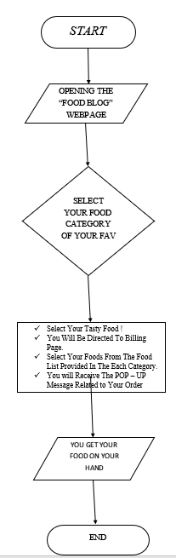

**Figure 2.1 Flowchart for Site Process**

**RESULTS AND DISCUSSIONS**

**3.1 OUTPUT SCREENSHOT**

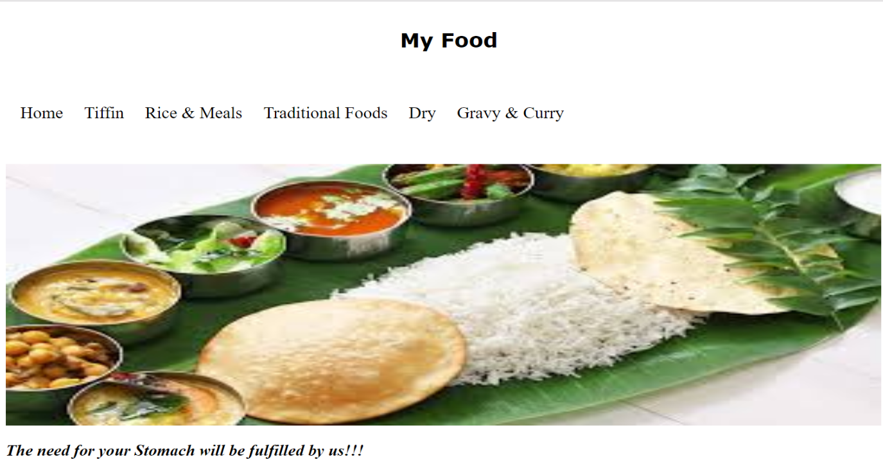

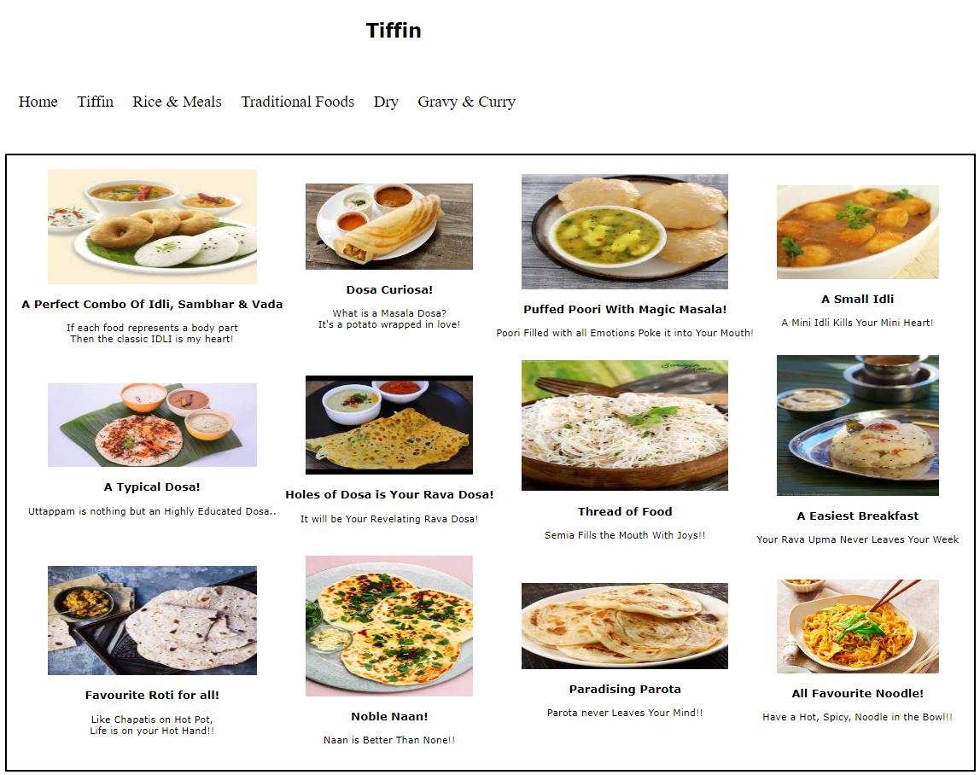**Figure 3.1 Home Page**

**Figure 3.2 Tiffin Page**

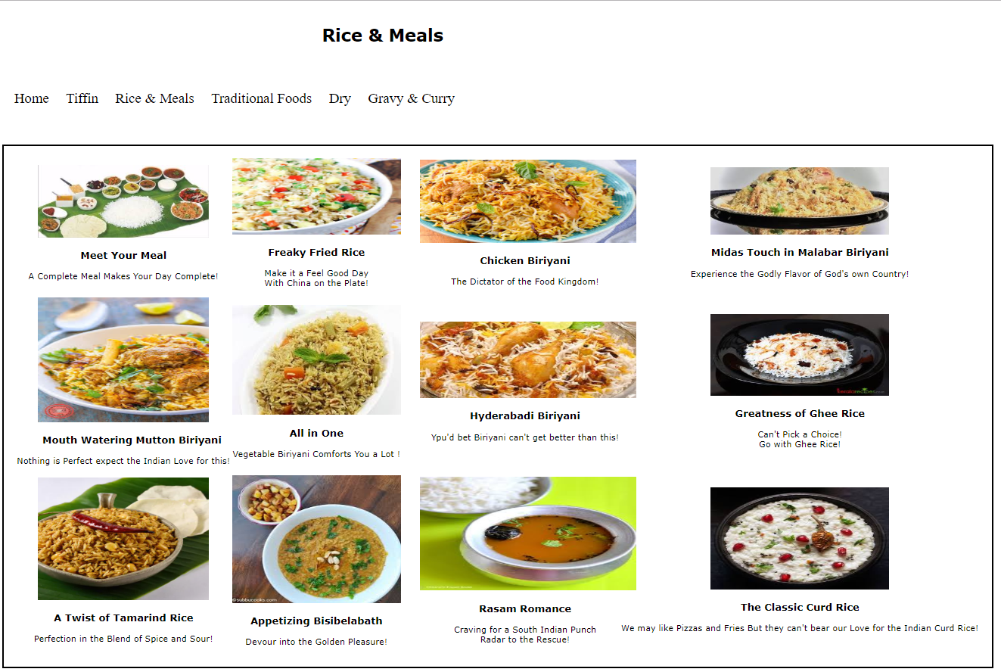

**Figure 3.3 Rice and Meals Page**

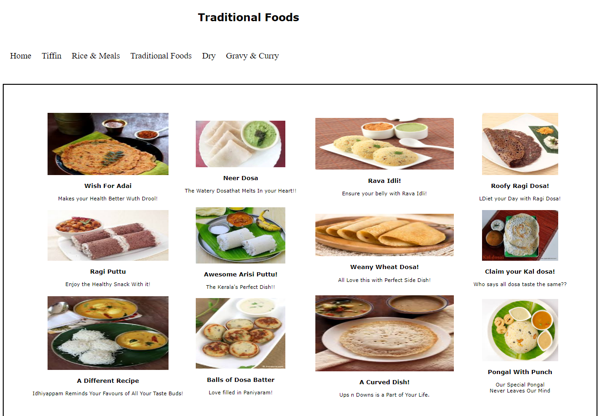

**Figure 3.4 Traditional Foods Page**

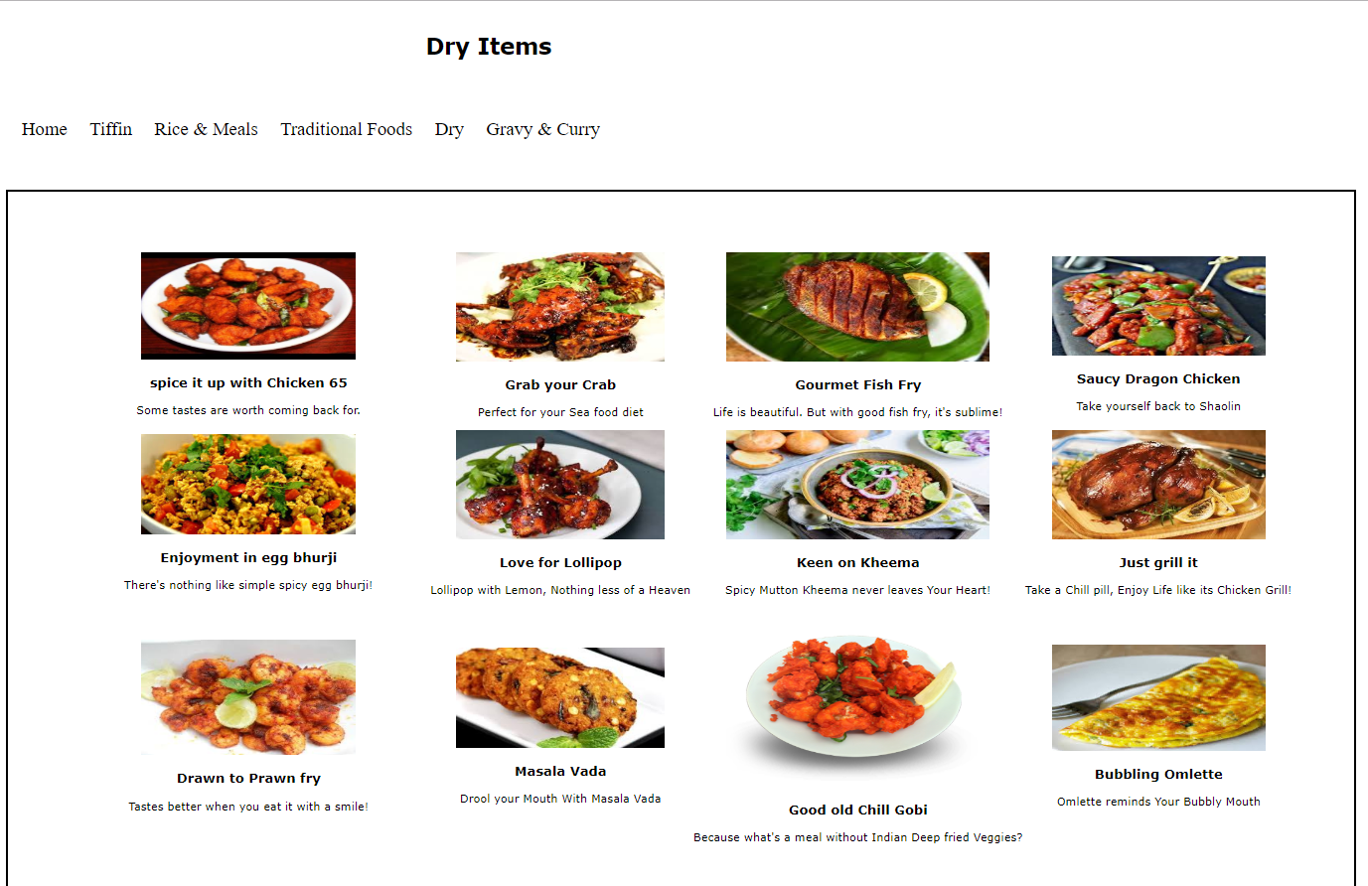

**Figure 3.5 Dry Foods Page**

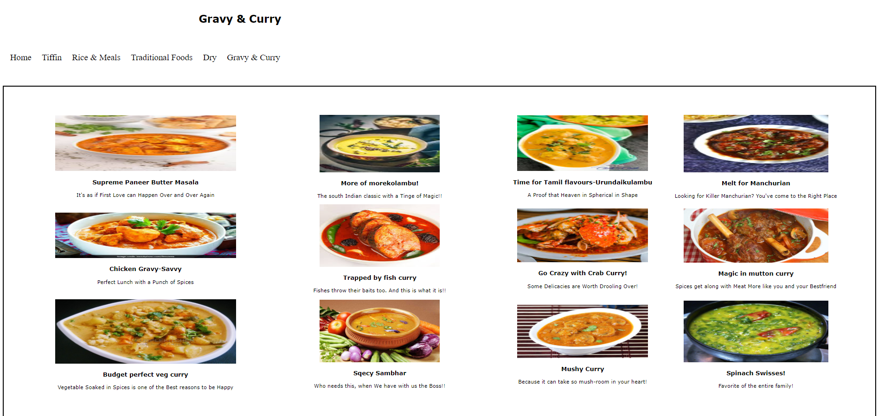

**Figure 3.6 Gravy and Curry Page**

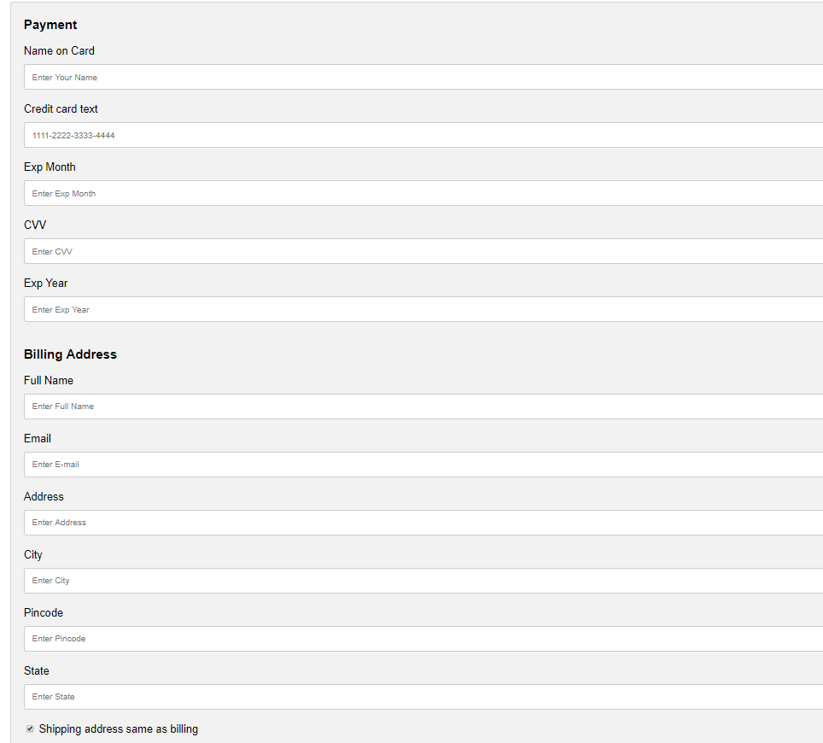

**Figure 3.7 Billing Page**

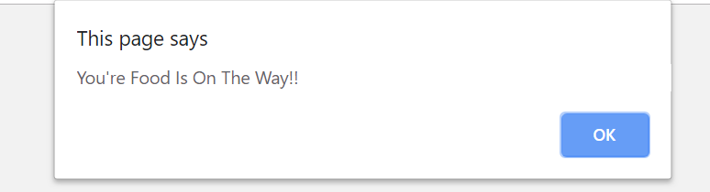

**Figure 3.8 Pop-up Message**

**3.2 DISCUSSION**

**Figure 3.1 Home Page:** The Home Page is the first and foremost page of the website. This page incorporates the links to different categories of entrées and appetizers. The user is enabled to click on these tabs to view the food items.

**Figure 3.2 Tiffin Page:** This page encompasses various food items largely consumed for breakfast or supper. The user is redirected to the billing page when he/she clicks on any image displayed.

**Figure 3.3 Rice and Meals Page:** This page encompasses of entrées ranging over different cuisines. The user is redirected to the billing page when he/she clicks on any image displayed.

**Figure 3.4 Traditional Foods Page:** This page consists of traditional food items belonging to the Southern States of India. This gives the customer the freedom to choose between international cuisines along with indigenous food items.

**Figure 3.5 Dry Foods Page:** This page displays a wide range of mouthwatering appetizers for the user to choose from.

**Figure 3.6 Gravy and Curry Page:** The users can choose from a wide range of rich and delightful gravies and curries as a side for their entrées. The user is redirected to the billing page when he/she clicks on any image displayed.

**Figure 3.7 Billing Page:** On clicking the images displayed, the user is redirected to an automatic billing system. The user is also given some other options to choose from.

**Figure 3.8 Pop-up Message:** If the order placed is successful, the user receives a pop-up message else he is redirected to a different page.

**CONCLUSION**

**4.1 CONCLUSION**

Thus, this is a model that is flexible enough to be open to changes and yet cling on to its founding principle of promoting indigenous cuisine of the country. The site stands representing a single place or restaurant in its incubation model and it intends to remain so amidst all the planned improvements to the site. The site will not be opened to other restaurants as a common platform like the other popular contemporary e-commerce site. The site will be maintained in terms of its ease of usage with utmost focus. The site is created taking inspiration from the existing successful models. But nothing has been blindly adopted from what has worked in the past. The originality of the site can be vouched for considering the design aspect of the site has been developed completely independent of other pre-designed templates that are available on the internet.

**REFERENCES**

1. Online food ordering practices

<https://en.wikipedia.org/wiki/Online_food_ordering>

1. Online billing system guidelines

<https://www.avidxchange.com/what-is-electronic-billing/>

1. Ecommerce guidelines of India

https://consumeraffairs.nic.in/sites/default/files/file-uploads/latestnews/Guidelines

1. Food ordering site creation

<https://www.spaceotechnologies.com/create-online-food-ordering-system-guide/>

1. Fundamentals of Web Development – Randy Connolly
2. Advanced HTML, CSS and JavaScript methods

<https://w3schools.com/>

1. Google Images for culinary pictures

<https://images.google.com/>

1. Thomas A., Powell, “HTML and CSS –The complete reference”
2. Don Norman, “Design of Everyday Things”